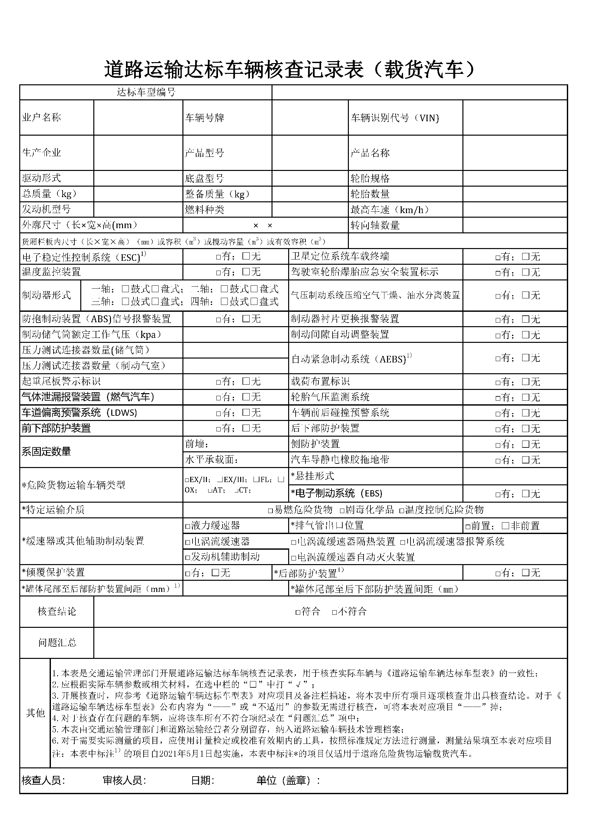

|  |  |  |  |  |  |  |  |  |  |
| --- | --- | --- | --- | --- | --- | --- | --- | --- | --- |
|  |  |  |  |  |  |  |  |  |  |
|  | ${owner} |  |  |  | ${platnum} |  |  | ${vin} |  |
|  |  |  |  |  |  |  |  |  |  |
|  | ${factoryName} |  |  |  | ${CPXH} |  |  | ${vehicleType} |  |
|  |  |  |  |  |  |  |  |  |  |
|  | ${QDXS} |  |  |  | ${DPXH} |  |  | ${LTGG} |  |
|  | ${ZZL} |  |  |  | ${ZBZL} |  |  | ${LTSL} |  |
|  | ${FDJXH} |  |  |  | ${RLZL} |  |  | ${ZGCS} |  |
|  |  | ${WKCC} | | | |  |  | ${ZXZSL} |  |
|  |  |  | | | | ${HXLBCC} | | |  |
|  |  |  | | | |  |  |  |  |